Managing worry and anxiety
As the COVID-19 pandemic continues to affect how we live, work and interact we are all trying to come to terms with the rapidly changing impact this is having on our lives. Like us, many people are worrying about the current situation, whether that is about our health, how we work, home life, finances or loved ones, and at times things can feel overwhelming.
Worry and anxiety are common problems at the best of times, and something that everyone deals with differently. But when those thoughts and feelings take over they can become all-encompassing and it can be very difficult to see a way through.
In previous editions of Workforce Matters we have looked at general advice on how we can all maintain our wellbeing and improve our resilience. In this edition we would like to look more closely at why we worry, ways of managing our feelings and importantly being aware of where to seek support if things are getting too much.
What is worry?
As human beings we have the amazing ability to think about future events. Thinking ahead gives us the opportunity to plan solutions to the challenges and opportunities we face in life.
This can be very positive, for example, hand washing and social distancing are helpful things that we can decide to do in order to prevent the spread of the virus. However, worrying is also a way of thinking ahead that can leave us feeling anxious or apprehensive. When we worry excessively, we often think about worst case scenarios and feel that we won't be able to cope.
What does worry feel like?
When we worry it can feel like a chain of thoughts and images which can sometimes progress in increasingly catastrophic and unlikely directions. It is natural that many of us may have recently noticed ourselves thinking about worst-case scenarios, and some people can experience worry as an uncontrollable series of steps that can seem to take on a life of its own.
The example below illustrates how worries can escalate quickly even from something relatively minor.
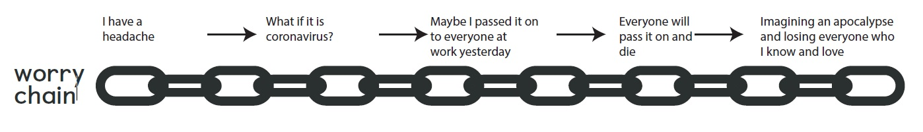

What triggers worry and anxiety?
Anything can be a trigger for worry, and we all react differently, but there are certain factors that can make it more likely.
Ambiguity – When things are open to different interpretations.
Novel and new – When we don’t have any experience to fall back or draw on.
Unpredictability – When it is unclear how things will turn out.
Does any of this sound familiar at the moment? The current worldwide health situation ticks all of these boxes, and so it makes sense that people are experiencing a lot of worry. It is an unusual situation with much uncertainty, which can naturally lead us to worry and feel anxious.
Are there different types of worry?
Worry can be helpful or unhelpful, and psychologists often distinguish between worries concerning ‘real problems’ vs. ‘hypothetical problems’.
Real problem worries – These are actual problems that need solutions right now. For example, there are real and achievable solutions that are in our control and that we can apply to the pandemic. These are things like following guidance on regular hand washing, social distancing, and physical isolation if you have symptoms.
Hypothetical worries – These might include thinking about worst-case scenarios and are often called catastrophising. Examples of this type of worry might be imagining scenarios such as ourselves or people we know becoming ill.
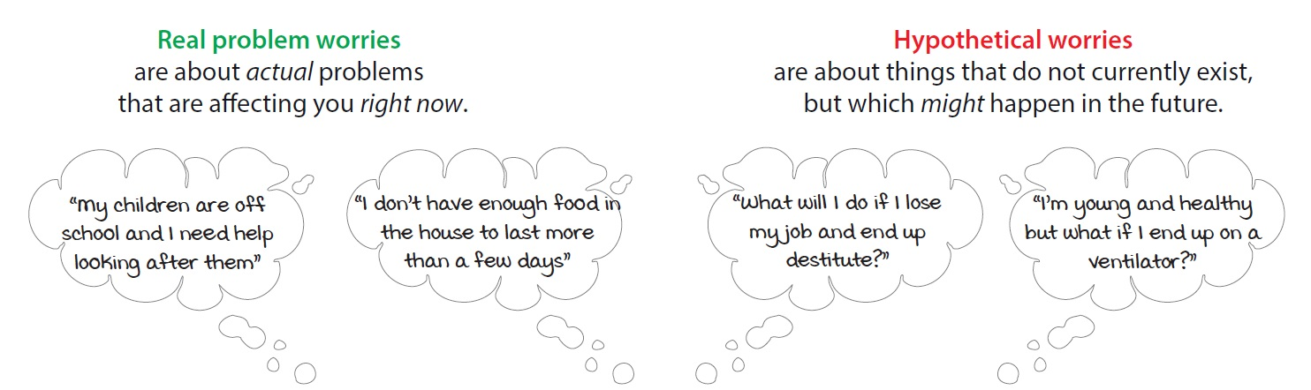

When does worry become a problem?
Everyone worries to some degree, and some thinking ahead can help us to plan and cope. There is no 'right' amount of worry, but it is important we are able to recognise when that worry becomes a problem, for example when worry stops you from living the life you want to live, or if it leaves you feeling demoralised and exhausted.
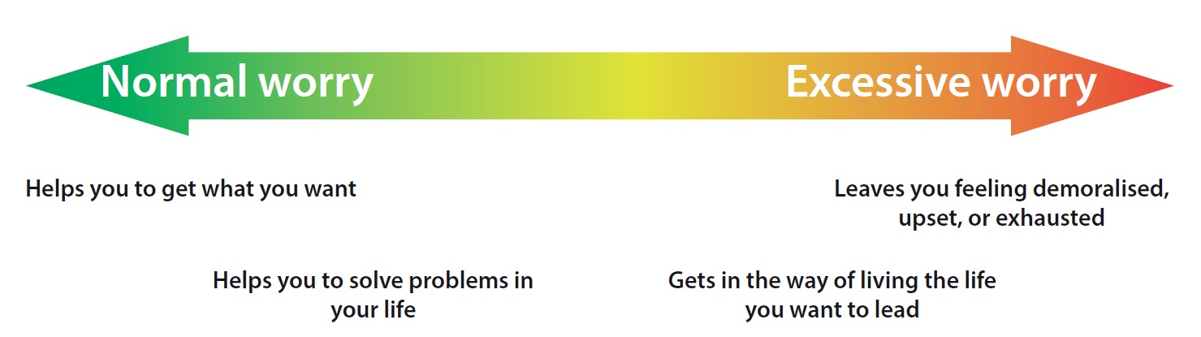
What can I do about worry?
It is natural for us all to worry at the moment, but if you feel that it's becoming excessive and taking over your life it might be worth trying to take some steps to manage your wellbeing:
Maintain balance in your life - Psychologists say that wellbeing comes from living a life with a balance of activities that give you feelings of pleasure, achievement, and closeness. The activity menu on the following page contains suggestions of activities to help you to distract yourself and stay active. Remember that we're social animals and we need connections to thrive and flourish however in times like these you might have to find some creative ways to do social things at a distance.

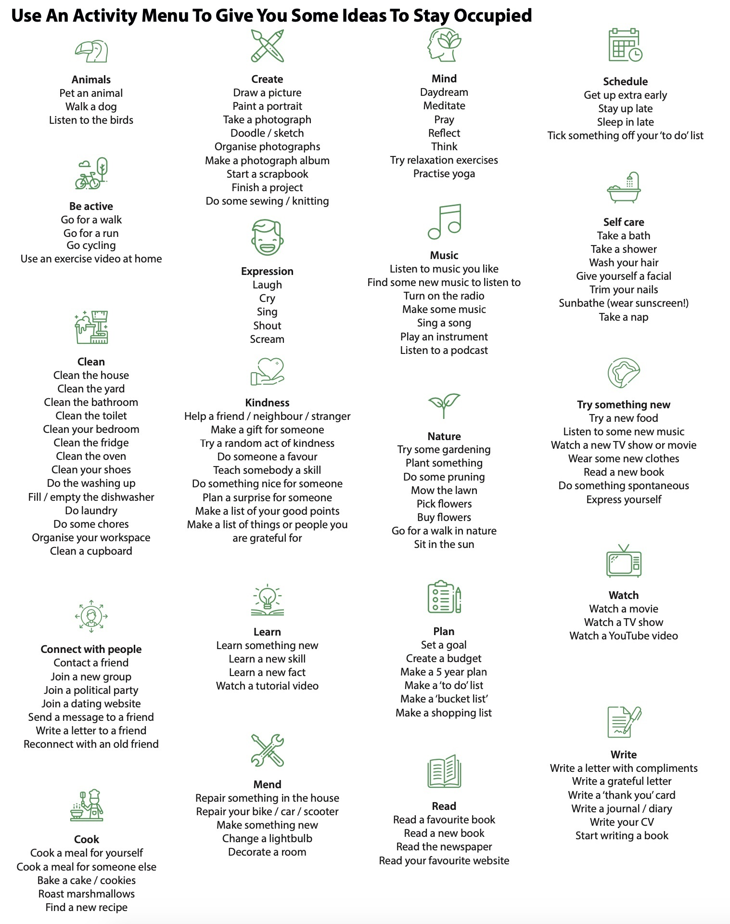

Identify whether your worry is 'real problem worry', or 'hypothetical worry' - The Worry Decision Tree is a useful tool for helping you to decide what type your worry is. If you're experiencing lots of hypothetical worry, then it's important to remind yourself that your mind is not focusing on a problem that you can solve right now, and then to find ways to let the worry go and focus on something else.
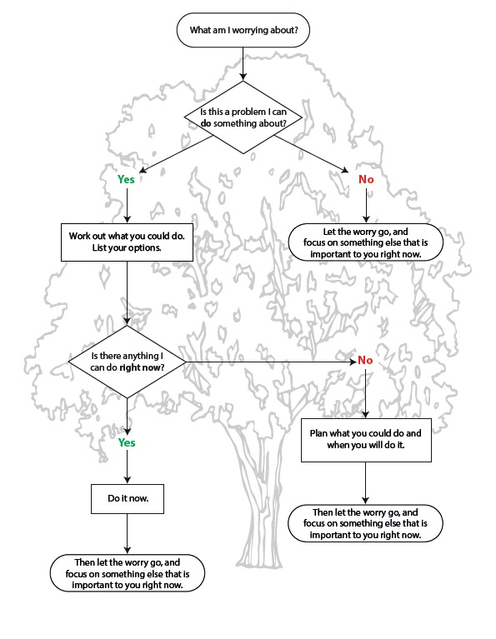

Practise postponing your worry - Worry is insistent! It can make you feel as though you have to engage with it right now. But you can experiment with postponing hypothetical worry, and many people find that this allows them to have a different relationship with their worries. In practice, this means deliberately setting aside time each day to let yourself worry (e.g. 30 minutes at the end of each day). It can feel like an odd thing to do at first! This means that for the other 23.5 hours in the day you try to let go of the worry until you get to your 'worry time'.

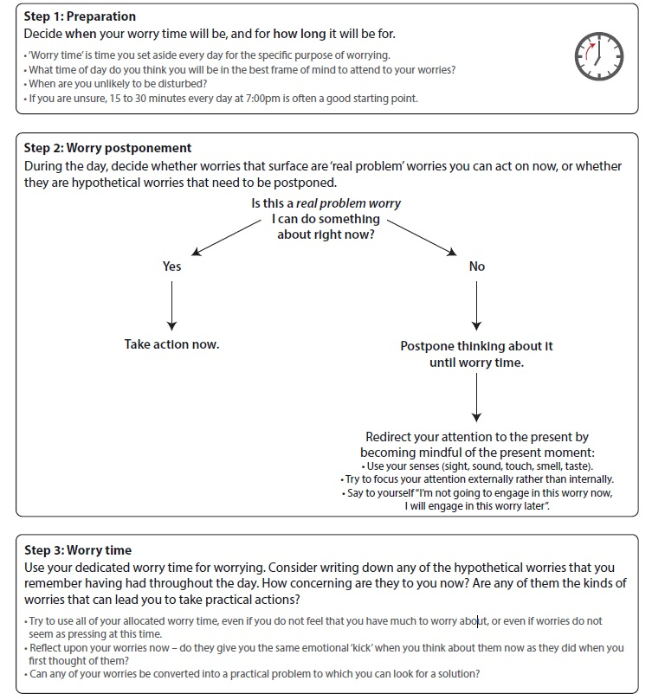

Speak to yourself with compassion - Worry can come from a place of concern. We worry about others when we care for them. A traditional cognitive behavioural therapy technique for working with negative, anxious, or upsetting thoughts is to write them down and find a different way of responding to them with kindness and compassion. Think about using the following headings to write your thoughts down:

- Think about the situation - Who were you with? What were you doing? Where were you? When did it happen?
- Think about the emotions and body sensations - What did you feel? (Rate intensity 0–100%)
- Automatic thought - What went through your mind? (Thoughts, images, or memories) if you had an image or memory, what did it mean to you?
- Your compassionate response - What would a truly self-compassionate response be to your negative thought? Try to respond to yourself with the compassionate qualities of wisdom, strength, warmth, kindness, and non-judgement.
• What would my best friend say to me?
• What would a truly compassionate being say to me?
• What tone of voice would I need to be talked to in order to feel reassured?

Practice mindfulness - Learning and practicing mindfulness can help us to let go of worries and bring ourselves back to the present moment. For example focusing on the gentle movement of your breath or the sounds you hear around you, can serve as helpful 'anchors' to come back to the present moment and let go of worries. The NHS provides further details on mindfulness here.
Shielding and worry

If you are among the group of people who have been asked to shield yourself for 12 weeks, worry and anxiety can be even more pronounced. While the intention of the guidance is to protect people who may be more susceptible to Covid-19, the impact on mental health, wellbeing and independence can be more significant.
Some people, who live perfectly normal lives with well controlled or managed underlying health conditions have reported that the restrictions have made them feel disempowered, isolated and marginalised. It's important to recognise that despite the current situation, you still have skills and talents that can be employed and while the way you do things may be different you are still able to be involved and make a difference.
If you are in this group the information in this document and previous editions of workforce matters may be especially useful in terms of managing worry and anxiety. The tools may also help you identify activities and different ways to remain engaged in your usual routines, social and work life. It's also important to remember you are not going through this on your own and there is excellent support and guidance available from organisational resources and condition specific support groups.

When worry becomes anxiety

Most people feel anxious at certain times. It's particularly common to experience some anxiety while coping with stressful events or changes, especially if they could have a big impact on your life. But anxiety can become a problem if it impacts on your ability to live your life as fully as you want to. For example, it may be a problem for you if are:
- Feeling tense or nervous
- Being unable to relax
- Worrying about the past or future
- Feeling tearful
- Not being able to sleep
- Not being able to enjoy your leisure time
- Having difficulty looking after yourself
- Having problems concentrating at work
- Struggling to form or maintain relationships
- Worried about trying new things
Anxiety isn’t just something that affects us psychologically, when it becomes excessive we feel it in our bodies too. Physical symptoms of worry and anxiety include:
- faster, irregular or more noticeable heartbeat
- feeling lightheaded and dizzy
- headaches
- chest pains
- loss of appetite
Further details about anxiety and mental health, including guidance and support is available via the NHS website.
Some final tips
Set a routine - If you are spending more time at home it is important to continue with a regular routine. Maintain a regular time for waking up and going to bed, eating at regular times, and getting ready and dressed each morning. You could use a timetable to give structure to your day.
Stay mentally and physically active - When you plan your daily timetable, have a go at including activities that keep both your mind and body active. For example, you could try learning something new with an online course, or challenge yourself to learn a new language. It’s also important to keep physically active. For example doing rigorous housework for 30 minutes, or an
online exercise video.
Practice gratitude - At times of uncertainty, developing a gratitude practice can help you to connect with moments of joy, aliveness, and pleasure. At the end of each day, take time to reflect on what you are thankful for today. Try and be specific and notice new things each day, example ‘I am grateful that it was sunny at lunchtime so I could sit in the garden’. You could start a gratitude journal, or keep notes in a gratitude jar. Encourage other people in your home to get involved too.
Notice and limit worry triggers - As the health situation develops it can feel like we need to constantly follow the news or check social media for updates. However, you might notice this also triggers your worry and anxiety. Try to notice what triggers your worry. For example, is it watching the news for more than 30 minutes? Checking social media every hour? Try to limit the time that you are exposed to worry triggers each day. You might choose to listen to the news at a set time each day, or you could limit the amount of time you spend on social media for news checking.
Rely on reputable news sources - It can also help to be mindful of where you are obtaining news and information. Be careful to choose reputable sources such as the BBC. The World Health Organization also provides excellent information on myths and fake news here

And remember, it's natural to struggle when times are uncertain, so remember to offer care and compassion to yourself, and to those around you!

Useful resources
Talking to another person can help. Lincolnshire’s new Mental Health Helpline is now open and available 24hrs a day on 0800 001 4331.
For more resources and advice on taking care of your mental health during the COVID-19 pandemic, please visit the Lincolnshire Partnership NHS Trust's website.
NHS Covid-19 Information:
https://www.nhs.uk/conditions/coronavirus-covid-19/
Government Covid-19 Information:
https://www.gov.uk/government/topical-events/coronavirus-covid-19-uk-government-response
World Health Organization (WHO) Covid-19 Information:
https://www.who.int/emergencies/diseases/novel-coronavirus-2019/advice-for-public
Mind
https://www.mind.org.uk
Rethink
https://www.rethink.org
Shine
http://www.lincsshine.co.uk/
Anxiety Care
www.anxietycare.org.uk
First Steps to Freedom
www.first-steps.org
No Panic
www.nopanic.org.uk
This resource is not intended to be, and should not be relied on, as a substitute for professional medical advice, diagnosis, or treatment. If you are suffering from any mental health issues we recommend that you seek formal medical advice.

