Looking after your mental health
It’s a challenging time for most of us as the evolving pandemic is rapidly changing every aspect of our lives. People may be feeling anxious, stressed and scared which is understandable.
It should be recognised that this situation is exceptional, and is bound to impact on our wellbeing, resilience and mental health. While we are all taking precautions for our physical health such as hand hygiene and social distancing, it's also important that we don’t forget about our mental health.
This edition of workforce matters provides useful information and links that we can all use to help support our mental health and wellbeing during this worrying time.
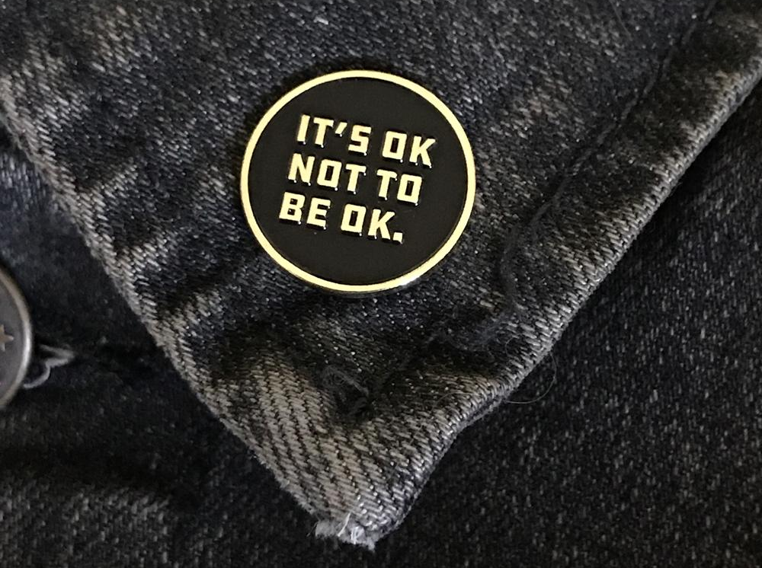

The coronavirus (COVID19) outbreak is going to have an impact on everyone’s daily lives, as the government and the NHS take necessary steps to manage the outbreak, reduce transmission and treat those who need medical attention.
It may be difficult, but by following guidance on social distancing, or staying at home, you are helping to protect yourself, your family, the NHS and your community.
For wider guidance on how to protect yourself and others, and actions to take if you think you may have contracted the virus please see the guidance on this page.
Whether you have to stay at home because of coronavirus (COVID-19), or the anxiety around the current situation is impacting you it's important to take care of your mind as well as your body.
You may be low, worried or anxious, or concerned about your finances, your health or those close to you, or may feel bored, frustrated or lonely.
It is OK to feel like this – everyone reacts in their own way to challenging events and uncertainty.
While this newsletter can't give solutions to the current situation, we can share advice, guidance and resources that are available to staff that may be useful to help you keep on top of your mental wellbeing and cope with how you may feel now and in the coming weeks.
Connect with others
Maintaining healthy relationships with people you trust is important for your mental wellbeing. Think about how you can stay in touch with friends, colleagues and family while you are at home – by phone, messaging, video calls or online – whether it's people you usually see often, or reconnecting with old friends or neighbours.
Lots of people are finding the current situation difficult, so staying in touch could help them too.
Talk about your worries
It is quite common to feel worried, scared or helpless about the current situation. Remember, it is OK to share your concerns with others you trust – doing so could help them too. Or you could try a charity helpline or webchat. The NHS lists numerous approved mental health helplines
A new confidential mental health and emotional wellbeing helpline has been launched
The new helpline, in Lincolnshire, is a joint initiative across health, social care and the third sector, is available 24/7 and can provide emotional support, advice and guidance if you are feeling low, anxious or stressed, and think you might benefit from speaking to someone.
By calling 0800 001 4331 you can speak to a member of a highly trained and experienced team of support workers who will be able to provide appropriate support.
Look after your body
Our physical health really affects how we feel. Try to make sure you and your family eat healthy, well-balanced meals, drink enough water and exercise regularly.
Avoid smoking or drugs, and try not to drink too much alcohol. It can be easy to fall into unhealthy patterns of behaviour that end up making you feel worse. Get outside for a walk or a run if you can, even take the dog on an extra-long walk, or try an online workout.
Stay on top of difficult feelings
Concern about the coronavirus outbreak is perfectly normal. However, some people may experience intense anxiety that can affect their day-to-day life. Try to focus on the things you can control, such as how you act, who you speak to and where you get information from.
It's fine to acknowledge that some things are outside of your control, but if constant thoughts about the situation are making you feel anxious or overwhelmed, there are some things you can try to help manage your anxiety. The NHS has a helpful mental wellbeing audio guide here.
Do not stay glued to the news
Try to limit the time you spend watching, reading or listening to coverage of the outbreak, including on social media, and think about turning off breaking-news alerts on your phone.
You could set yourself a specific time to read updates or limit yourself to checking a couple of times a day.
Use trustworthy sources – such as the BBC, GOV.UK or the NHS website – and fact-check information from the news, social media or other people.
Carry on doing things you enjoy
If we are feeling worried, anxious, lonely or low, we may stop doing things we usually enjoy.
Make an effort to focus on your favourite hobby if it is something you can still do at home. If not, picking something new to learn at home might help – there are lots of ideas online.
Take time to relax
This can help with difficult emotions and worries, and improve our wellbeing. Relaxation techniques can also help deal with feelings of anxiety.
If you notice increase worry or anxiety, you could try the Apple Technique:
- Acknowledge – notice the uncertainty as it comes into your mind
- Pause – pause and breathe (don’t react at all)
- Pull Back – tell yourself that it’s just the worry talking. The apparent need for certainty is not necessary or helpful. Thoughts are not always facts.
- Let Go – let go of the thought or feeling. It will pass. You don’t have to respond to it. Visualise it passing by like leaves in a stream.
- Explore – explore right now. Notice your breathing, and then what you can see, what you can hear, what you can touch and what you can smell. Then shift your attention back on to what you were doing or on to something new.
(Anxiety UK)
Stick to daily routines as far as possible
Think about how you can carry on your normal routines, and try to do things that are useful or meaningful. For example, if you are working from home, try to get up and get ready in the same way as normal, keep to the same hours you would normally work and stick to the same sleeping schedule.
If you cannot do this, think about how you can create new routines and set yourself goals. You could set a new alarm for the morning, do a daily home workout, and pick a regular time to clean, read, watch a TV programme or film, or cook.
There are plenty of things you can do and places to get more help and support if you are struggling with your mental health. The NHS pages on stress, anxiety, sleep and low mood have lots more tips and specific advice
Look after your sleep
Good-quality sleep makes a big difference to how we feel, so it's important to get enough.
Try to maintain your regular sleeping pattern and stick to good sleep practices.
Keep your mind active
Read, write, play games, do crosswords, complete Sudoku puzzles, finish jigsaws, or try drawing and painting.
Whatever it is, find something that works for you.
Information provided by https://www.nhs.uk/oneyou/every-mind-matters/

Working from home can also pose challenges for people. Even if you are used to doing this on a regular basis, doing this long term can be quite different. So if you're self-isolating, social-distancing or working remotely, what's the best way to stay efficient and keep your spirits up?
Stick with your routine
Just because you're not traveling to go into an office doesn't mean you should skip your weekday morning preparations. Wake up at your normal time, and try and follow your normal routine. It may sound trivial, but this helps you mentally prepare for the day ahead and get into the "I'm going to work" mind-set.
It's also helpful to keep a set schedule. If you typically work nine-to-five hours, keep doing it at home. Don’t forget to take your lunch break, it's easy to lose track of time and if you can't stick to a typical work-life balance, you may find yourself getting easily burnt out.

Create a work space
Although it's tempting to head to your sofa, those who successfully work from home agree that you're best off setting up a station. If you don't have a desk, use your dining room table. Besides making you feel like you're at an "office," this helps you maintain good posture, avoid distractions, and leave your work behind at the end of the day.
Don't just sit there
Sitting all day isn't healthy even if you're at the office, but working from home means you skip your commute and have fewer reasons to get up from your chair throughout the day to stand up regularly to stretch or move around.
If you've gained an extra hour or two from not commuting, it's a good opportunity to exercise, either by working out at home or going for a walk outside. A lunchtime walk can also help you feel like you're not stuck inside all day.
Get some fresh air
As we need to limit contact with people, you're likely going to spend a lot of time indoors. Open your windows to let in as much natural daylight and fresh air as possible, and take short walks if you live in an unpopulated area — and be sure to wash your hands as soon as you return home.
Stay connected with your colleagues
If you work in a team, make sure to check in regularly just like you would in the office. Create to-do lists to keep yourself organized and focused, and share the status of your lists with your supervisor so they know you're on top of your work. Besides email and messaging programs it's a good idea to set up regular check-ins via phone or video conferencing
One of the most important things to remember is none of us is in this alone. You are still part of a team, and talking to each other is very important. Your managers or supervisors are also still available to support you, and while supervision may be done differently, it is still expected that staff receive some form of supervision.
Fake News?
Be mindful of the sources of information you come into contact with and the validity of their source. Many articles and claims about COVID-19 are being shared widely on social media and less reputable media streams. While these may purport to come from reliable sources, it is vital that we follow and share only information from trusted sources such as the NHS and Public Health. The impact of incorrect information or false claims about preventions, treatments and symptoms could put you or others at risk.

Practical issues
Think about how you can get any supplies you need – many supermarkets are now offering a slot for keyworkers or ask a neighbour, family, friends or if you can use a delivery service, so you don’t worry about running out. Try to pick healthy food, especially as you might not get as much exercise as normal. Remember your Keyworker Identification to show should you be asked why you are in public.
If you care for other people
You may be worried about how to ensure care for those who rely on you – either your dependents at home or others that you regularly visit. Let your local authority know if you are unable to continue to do so. You can contact Lincolnshire County Councils Customer Service Centre on 01522 782155 if you have concerns about someone.

General COVID-19 advice
Easy Read Coronavirus guidance
keeping your mind and body well
NHS Information:
https://www.nhs.uk/conditions/coronavirus-covid-19/
NHS Mental health helplines-Whether you’re concerned about yourself or a loved one, these helplines can offer expert advice.
https://www.nhs.uk/conditions/stress-anxiety-depression/mental-health-helplines/

Government Information
https://www.gov.uk/government/topical-events/coronavirus-covid-19-uk-government-response

Guidance for the public on the mental health and wellbeing aspects of coronavirus (COVID-19)
https://www.gov.uk/government/publications/covid-19-guidance-for-the-public-on-mental-health-and-wellbeing/guidance-for-the-public-on-the-mental-health-and-wellbeing-aspects-of-coronavirus-covid-19

World Health Organization (WHO)
https://www.who.int/emergencies/diseases/novel-coronavirus-2019/advice-for-public

Mind
https://www.mind.org.uk/information-support/coronavirus-and-your-wellbeing/

Rethink
https://www.rethink.org/news-and-stories/blogs/2020/03/managing-your-mental-health-during-the-coronavirus-outbreak/
Shine
http://www.lincsshine.co.uk/

Taking Care of Yourself When Managing Others
https://www.ckju.net/en/dossier/manager-health-and-wellbeing-taking-care-yourself-when-managing-others/26106

