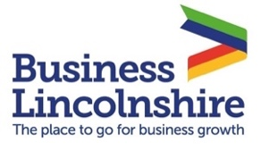
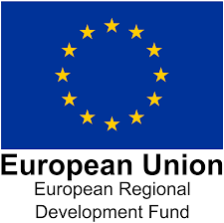
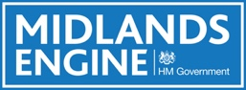

What Recovery Might Look Like When It Comes – by Hotel Solutions

For more than 20 years Lincolnshire based business Hotel Solutions has been dedicated to helping UK destinations to understand how they can best support hotel and visitor accommodation development in their area. With the current COVID-19 crisis their focus has shifted to helping destinations to look at how they can help their hotel and visitor accommodation industry to survive this unprecedented crisis and start to plan their recovery once it looks like coming to an end. As a starting point in this process they have compiled a paper to look at how UK hotels and visitor accommodation businesses have been affected by the lockdown, what recovery might look like for the industry when it comes, and how DMOs, local authorities and government can best support the sector over the next 6 to 12 months. The paper is based on analysis of a wide range of research reports and articles that have been published on the impact of the COVID-19 lockdown on the travel, tourism and hospitality sectors, including surveys with DMOs, local authority Tourism Officers, and hotel and visitor accommodation developers, operators and investors.

While the current crisis is clearly having a dramatic impact on the UK tourism and hospitality sector, all indicators point to an eventual market recovery. Going on holiday, seeing friends and family and having a day out are all high on people’s wish lists for when restrictions are lifted. Once the crisis is over people will want to travel again. While Britons look set to skip their summer holiday as international travel seems nigh on impossible this summer, people are keen to book staycation breaks from the autumn if they can.

All commentators expect domestic travel to recover more quickly than overseas travel.
Fewer domestic trips have been cancelled and the majority of those cancelling UK trips intend to rebook once things return to normal. Only a minority expect this to be before the summer. Day trips and staycations are likely to recover quickest and may see strong growth in the medium term, once normal trading resumes.

The scientific evidence shows that COVID-19 spreads more easily indoors that outdoors.
Restrictions on holidays and short breaks in the outdoors are likely to be lifted sooner therefore, suggesting that rural destinations and accommodation businesses may come out of the crisis more quickly than those in urban locations. People are likely to initially avoid city breaks and trips to crowded places, such as seaside resorts.

Inbound tourism is likely to take longer to return. Short-haul demand looks set to recover first, with demand from long-haul countries taking longer to rebuild.

Business travel looks likely to be slower to return, with many companies placing restrictions on travel budgets and looking to do business as cost effectively during the likely impending economic recession. The massive shift to doing business online during the lockdown may have a significant lasting impact on business travel if it continues once restrictions are lifted.

The conference and exhibitions market is likely to take some time to recover. Industry professionals do not expect the business events market to return to any semblance of normality for at least 12 months7. The increase in Zoom conference calls during the lockdown may become the norm going forward, dramatically reducing demand for face-to-face meetings and conferences as a result.

The indications at this stage point to a likely phased lifting of restrictions. Hospitality businesses will need to adapt to a ‘new normal’, with social distancing measures, extra cleaning regimes, the wearing of face masks, and possible restrictions on guest numbers.

Hotels may be allowed to reopen their bedrooms ahead of their bars and restaurants. It may be difficult for some hospitality businesses to restart profitable operations under these circumstances. Reopening may not be viable if operating losses are likely to be more than the costs of keeping hotels closed.

The Long-Term Impact on Consumer Behaviour

Euromonitor predicts that the COVID-19 pandemic will bring about lasting changes in consumer attitudes and behaviours. Consumers, including older demographics will do more things online. Social media use has increased. Health and wellbeing will be much higher on people’s agendas. People will want to get outdoors more and connect with nature and the environment. People will value spending time with family and friends more highly. The pandemic will accelerate a shift to a cashless society. The environmental bonus of the crisis may bring tackling climate change into sharper focus. These trends will further accelerate the trend towards online researching and booking of holidays and breaks. They could also change the types of destination, accommodation and holiday experiences. What is clear is that we all need to re-think and re-evaluate our old offer and prepare for the new normal!

To download the full report please click here:

https://www.hotelsolutions.org.uk/

